For the Attention of Our Pupils

Reporting Abuse
Child Protection during COVID-19 Lockdown and School Closure

Dear pupil if you have a concern about yourself or one of your school friends please email any member of the child protection team (Mrs Shilliday, Mr Thompson, Mrs Irvine or Mrs J Moore) at the school info account info@drumglasshigh.dungannon.ni.sch.uk
If you are not comfortable writing down your concern you can leave a name and contact phone number and a time when it is safe for you to talk and we will phone you back.
WE ARE STILL HERE FOR YOU
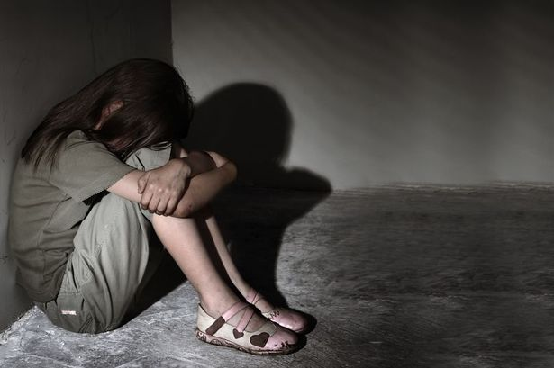
Telephone and Web Support for Young People

Who can  Help? | What Do  They Do? | What Topics Can They  Help With? | How Can They be Contacted?
Anna Freud National Centre | Supporting young people’s mental health during periods of disruption | Anxiety  Mental health | www.annafreud.org
Lifeline | Crisis response line for people in distress or despair | Depression  Mental health  Suicidal thoughts  Textphone users (for deaf and hard of hearing): | 0808 808 8000  18001 0808 808 8000
Childline | Childline provides support and guidance on multiple topics including: | Bullying  You and your body  Home and Family  Relationships  Sex  School | 0800 1111  www.childline.org.uk  1-2-1 counsellor chat
The MIX | Crisis messenger text service | Alcohol  Homelessness  Suicidal thoughts  General advice  Mental health  Sex/ relationships | 0808 808 4994
NSPCC | Advice on safeguarding and child protection issues and somewhere to report concerns  Web support for teenagers | Safeguarding  Child abuse  Child protection | 0808 800 5000  www.there4me.com
Aware | Aware is a mental health charity working exclusively for those with depression and mental health concerns | Depression  Bipolar disorder | 02890 357 820
Frank | Confidential advice on drugs | Alcohol  Drugs | 0300 123 6600
SIMON Community | Support for individuals and families who are at risk of becoming homeless | Homelessness  Housing | 0800 171 2222
Informing Choices NI | Advice on sexual health | Sexual health  Pregnancy  Contraception  STDs  Access to family planning | 0345 122 8687  Monday - Friday 9-5
Common Youth Clinics | Clinics, advice & guidance on sexual health | Emergency contraception  Pregnancy testing  Counselling | 02890 328 866
Domestic and Sexual Violence Helpline | Advice for anyone affected by domestic and sexual violence | Domestic violence  Sexual violence | 0808 802 1414
The Migrant Centre NI | Financial Health and Well being |  | euss@migrantcentreni.org
Cara-Friend/  LGBT Switchboard NI | Support and counselling for the Gay, Lesbian and Transgender communities | LGBTQ+ advice  Sex and relationship advice | 0808 8000 390
Women’s Aid | Specialist services for women, children and young people who have experienced domestic and sexual violence. | Domestic Violence  Sexual violence  Relationships | 0808 802 1414
Family Support NI | Website to access support in your area – for a wide range of issues – giving local contact details |  | www.familysupportni.gov.uk

Stay Safe
Signed Mrs Shilliday, Principal

